Experiment: 5

Simulation and Throughput Analysis of LTE-Advanced Carrier Aggregation

Program:
clc; clear; close all;
BWcc = 20; % MHz per component carrier
SE = 4; % bits/s/Hz
CC = [1 2 3]; % Number of component carriers
AggBW = BWcc .* CC; % MHz
Throughput = AggBW .* SE; % Mbps
disp('CC Aggregated BW (MHz) Estimated Throughput (Mbps)')
disp([CC' AggBW' Throughput'])

figure
bar(CC,Throughput)
grid on
xlabel('Number of Aggregated Component Carriers')
ylabel('Estimated Throughput (Mbps)')
title('LTE-Advanced Carrier Aggregation Throughput')

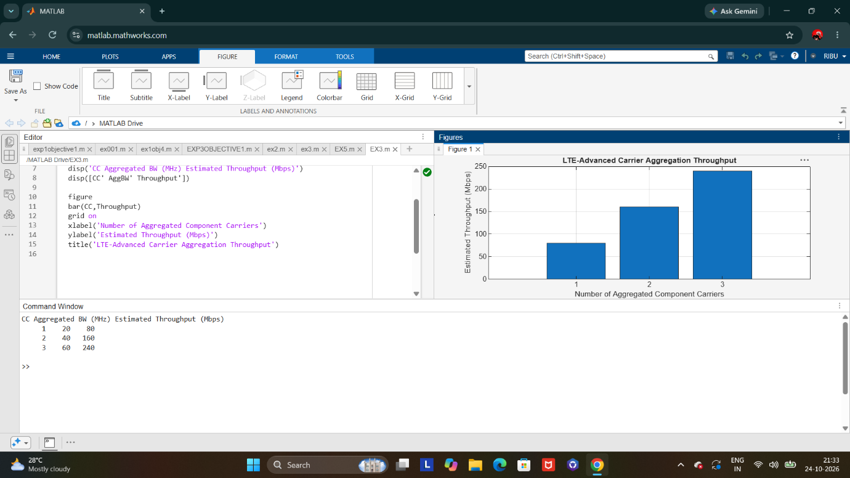

PROGRAM:
BW = [5 10 15 20]; % Carrier bandwidths (MHz)
SE = 4; % bits/s/Hz
TP = BW .* SE; % Estimated throughput (Mbps)
disp('Bandwidth (MHz) Throughput (Mbps)')
disp([BW' TP'])

figure
plot(BW,TP,'o-','LineWidth',2)
grid on
xlabel('Carrier Bandwidth (MHz)')
ylabel('Estimated Throughput (Mbps)')
title('Throughput vs Component Carrier Bandwidth')

